|  |  |
| --- | --- |
| Evidences Required | Results |
| Method of extraction | Execute query |
| User extraction process performed by | Bru,Jose |
| Users list count per screenshot should match with the actual users list submitted | 07 |
| Date when the users list was extracted | 08/30/2017 |

# HPA User List Extraction

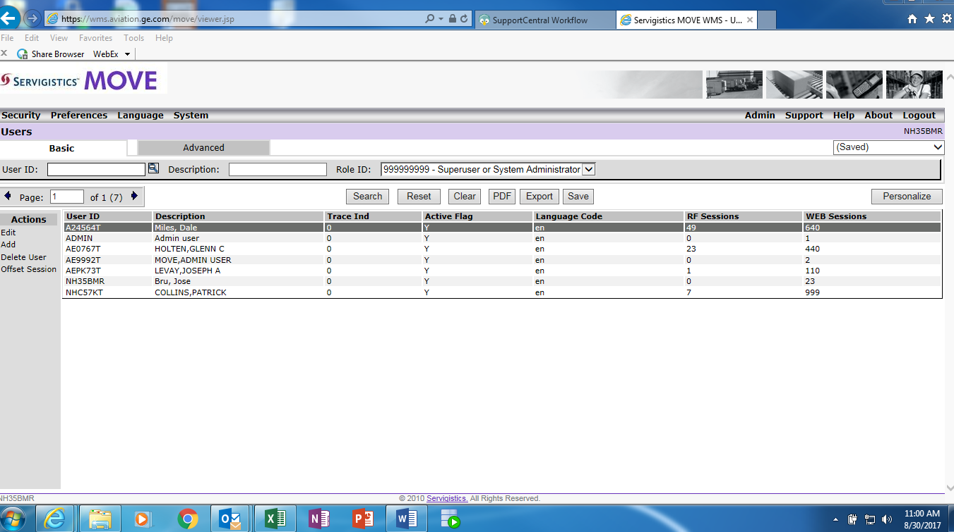

Attached is the HPA user list in excel format with authorized owner information.

